Replace headlight units without removing lower bumper.
Remove 4 Torx T20 from the grill under the hood.
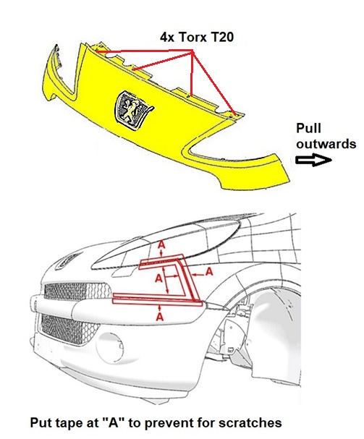
Using a spatula, make some space between the grill and the front fender. Then pull the grill, where it hits the front fender, outwards. First with one finger on the bottom and then on the top. The grill is quite clamped but is very flexible. Similarly on the other side. Now the grill can be removed to the front, it is only attached with sliding cams in the lower bumper.
Remove the electrical connector of the headlight unit.
Remove the rear bolt, wrench size 10, on the top back of the headlight unit.
At the front of the unit, at the location of the turn signal lamp, remove the bolt with wrench size 10 from the metal plate. This small metal plate stays on the headlight unit and must be transferred to the new one before assembling the unit in the car.
Now the most difficult bolt, this is located at the bottom of the headlight unit.
With a tapered drill I made a hole in the plastic of the bumper at the front, about 27 mm, large enough to let through a socket wrench 10mm with a universal joint and long extension bar.
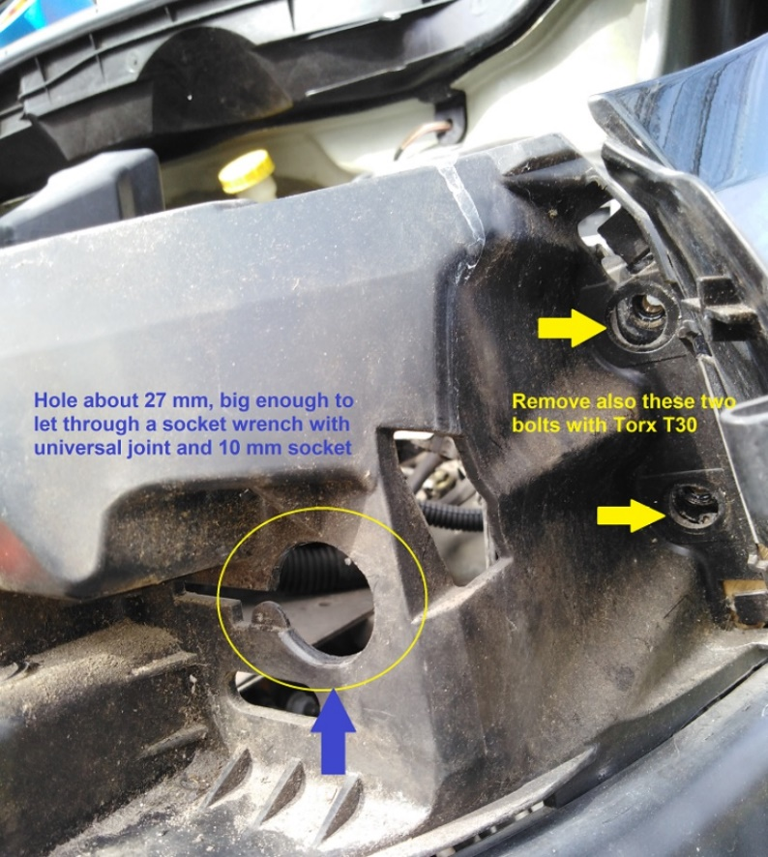
The bolts on the bottom of both units were not very tight, I could easy loosen them by hand without use of the ratched handle.
The most difficult part is to put the socket on the bolt, you cannot see this bolt, everything has to be done by touch.
Therefore I first replaced the unit on the right side. Here you can feel with your fingers the position of the socket and the bolt. On the left side there is less space for your arm to reach the bolt.
I also took out the two bolts Torx T30 behind the flap that secure the lower bumper and unclipped the bumper on the top of the radiator. Doing so there is more room to remove the headlight unit.

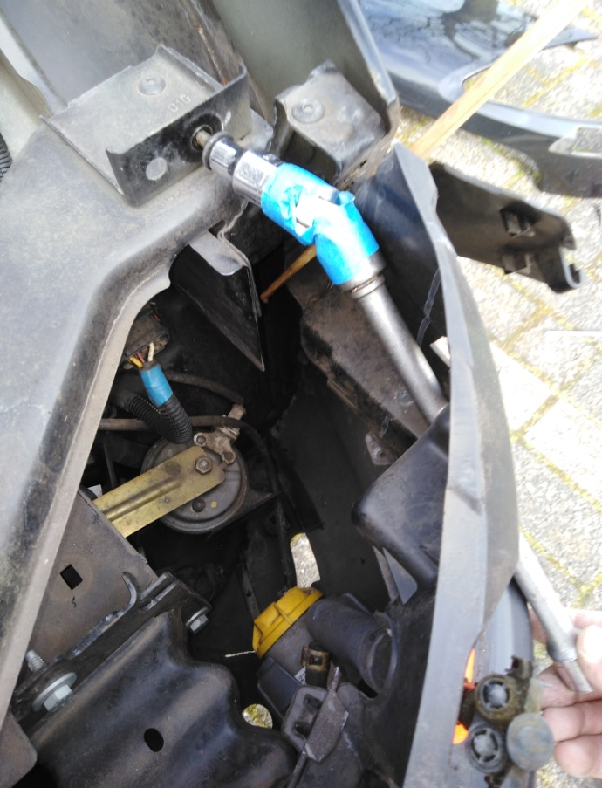
I put some blue tape around the universal joint to keep it in a certain position, learned from the right side when the headlight unit was removed.
When installing the new headlight units, I did not reapply these bolts, the units are kept in place with position pins and with the two existing bolts the units are well secured.
Because my car is provided with headlight washers I also had to remove the cover plates of the washers before I could take out the grill. For this I printed (3D) two clamps. By hand pull out the washer to the most outer position. On the washer shaft there are two flat sides (12mm) where you can put in the clamp. Then the shaft is hold in a specific position so the cover plates of the washers can be detached.
